TeacherSquared Lab #2: Playbook
Eliciting and Interpreting Student Thinking

Lab Group #1: Listening

Executive Summary (to be completed by COB Friday, Dec 2)

Short description of your group’s work <Probably wait until Friday PM to fill this out>

Concrete Documents/Products:

What are the concrete products that you created? <Probably wait until Friday PM to fill this out>

- Product Name (hyperlinked): Brief description

Group Members
Keep in mind that members of our learning community may reference this playbook in the future. Therefore, please include your contact info if anyone has questions about your work.
Name, Institution, and Position | Contact Information (Email and/or Phone) | Content Speciality (e.g., ELA, Math, Science, Special Education, etc…) | Role in the Group (for example...)  - Playbook Facilitator: Preview the playbook and drive the group forward  - Primary Note Taker within the Playbook  - Time Facilitator  - Airtime Monitor  - Other roles?

Helpful Links
- Call or Text Brent: 956-376-6888
- Call or Text Sona: 201-562-3318
- Lab Agenda
- Lab Participant Workbook
- Lab Deck
- Shared Google Folder for this Lab

Other Playbooks
#1: Listening  Folder | #2: EIST Rubric  Folder | #3: Teaching Excellence EIST  Folder | #4: Urban Teachers EIST  Folder

TABLE OF CONTENTS

- Group Members
- Lab Group Sprint #1: Identifying Goals and Deliverables
- Lab Group Sprint #2: Designing Materials
- Lab Group Sprint #3: Internalizing Feedback and Prepping for EIST Inspiration
- Lab Group Sprint #4: Process Feedback, More Design, and Prepping for Residents
- Lab Group Sprint #5: Planning for the Future

SPRINT #1: Identifying Goals and Deliverables

In this sprint you will clearly define what you want to accomplish over these next two days, think through how you will know if what you create is any good, clearly articulate any assumptions you are making, and find any concrete resources that you already have that might be helpful to your group.

Section 1.1: Goals for this Laboratory

Revisit the agenda for this lab and skim the rest of this playbook. Once you’ve got your head around the general structure of our time together, please articulate your group’s goals. Be as specific/concrete as possible, for example, you might want to name specific resources you plan on making.

By 3:00PM on Friday we will have accomplished the following:

**HINTS**
- Set goals that can be accomplished within this timeframe. When we leave here, our lives get crazy again. Think of this as protected time to create, innovate, and collaborate.
- Create materials that will be helpful to you and your program. Don’t just do something for the “good of the commons”...although having utility beyond your program probably suggests that it would be helpful to other teacher educators beyond TeacherSquared--and that is part of the TeacherSquared mission.

Section 1.2: Beginning with the End In Mind

Begin with the end in mind. What sort of pilot / feedback will you need to collect (likely after this lab) to know that what you’ve created is any good?

How will you know whether what you have created is any good?

**HINTS**
- Design/plan with an eye toward short-cycle piloting. How might you test back at your home institution what you created here to know if it should be used more broadly in your program? What sort of evidence would you find compelling?
- You will have a chance to revise this and commit to piloting on Friday afternoon.
- Throughout this process, keep thinking of how you will be able to measure the success of your product(s): adoption, usage, survey feedback, impact, etc.

Section 1.3: Assumptions

Please describe any assumptions you are making that are related to your materials (e.g., especially applicable to a particular content area, etc.). Assume a public audience may read this playbook; therefore, please mention any elements that may be idiosyncratic to your institution.

Section 1.4: Collection of Resources

Please collect any existing resources in your lab group’s folder that will be important for your work together. If it is helpful to list those resources here with direct hyperlinks, go for it!

Section 1.5: Dive In!

If you’ve accomplished everything above, go ahead and transition to Sprint 2: Designing Materials.

SPRINT #2: Designing Materials

In this sprint you will have two and a half hours to put your heads down and design. Adhere to our norm of not letting perfect be the enemy of good and create/refine as many materials as you can. Knowing that you’ll be sharing with other groups at the end of this sprint, be thinking about how you would like to focus the other group’s review/feedback.
TIMEKEEPER: Ensure you save at least 10 minutes to brainstorm focused questions for your peer feedback group.

Section 2.1: Goals for this Sprint

Preview the the content of this sprint and clearly articulate your goals for this time.

By 3:30PM today (end of sprint 2) we will have accomplished the following:

Section 2.2: Produce with Urgency

Go! Create some great materials!!!

Section 2.3: Questions for Formative Feedback Session

In the next session, you’ll have an opportunity to workshop what you’ve done so far with another group. Each group will have as much as 40 minutes to get feedback and support. Decide on the context that you need to give the other group and determine the specific questions you have for them.

What is the key context that you need to share with the other group? List your talking points here.

What are your specific questions / wonderings / requests for resources? On what do you most want to get feedback from your colleagues? List your guiding questions here.

FEEDBACK/NOTES
NOTETAKER: Compile the feedback you receive here.

**HINTS**
- If you are working on an actual session, consider actually practicing/teaching that session for the other group--or at least a tricky part of it.
- Consider creating copies of your materials/documents and creating direct links for the other group to click into / leave feedback on. If it’s an online document, link it in your playbook or create a TinyURL.
- If it makes sense, consider dividing your groups so that you can go more deeply on particular topics.
- Preview the content area expertise of the group that is providing feedback to you. Are there specific people you want to provide feedback on particular bits of what you’ve created?

SPRINT #3: Internalizing Feedback and Prepping for EIST Inspiration

In this sprint you will take the feedback that you just received, determine what changes you might want to make, and figure out what what you want to share with the whole group tomorrow morning.

Section 3.1: Goals for this Sprint

Preview the the content of this sprint and clearly articulate your goals for this time.

By 5:45PM today (end of sprint 3) we will have accomplished the following:

Section 3.2: Consider Feedback

Think about the feedback that you just received. Prioritize what you want to change. Capture it here so that you can pick up here easily tomorrow.

Section 3.3: Prep for EIST Inspiration Session

Tomorrow morning, each lab group will have 20 minutes to give a mini-presentation / demonstration on what they are currently working. Think of this activity as equal parts inspiration for other groups and an efficient way to crowdsource input/feedback/solicitation of targeted resources.

In preparation, please complete the five yellow cells in your group-specific feedback tab in the participant worksheet. TeacherSquared Labs: Practice <Participant Worksheet>, Tab: Group#-Feedback
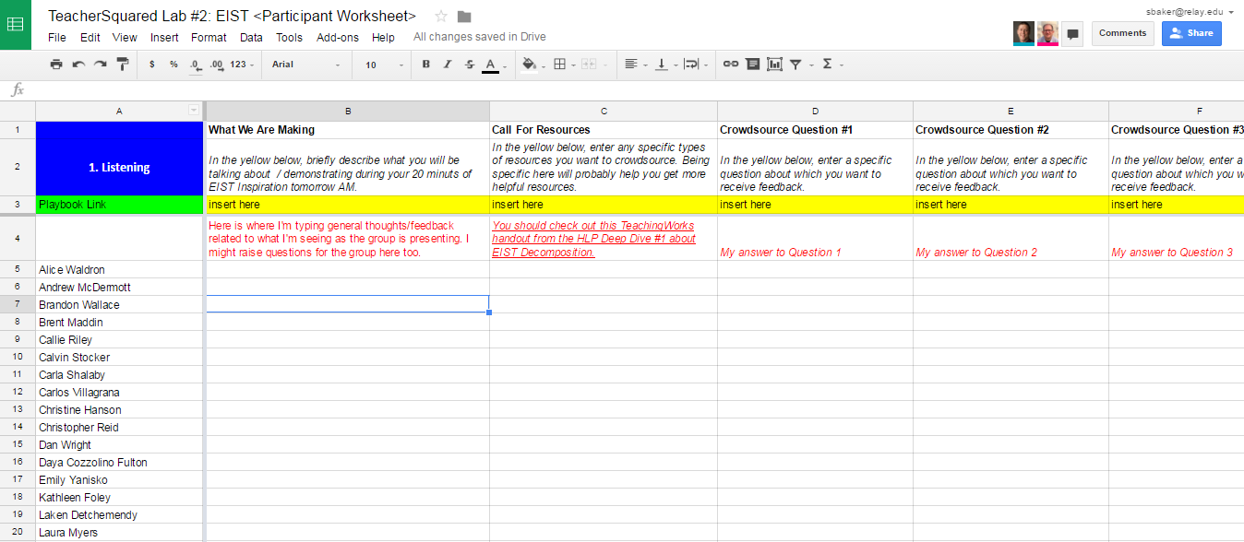

**HINTS**
- Feel free to create direct links to documents/resources in the spreadsheet for your colleagues to click on tomorrow, if you think that it will be easier for them to read on their computers instead of the projector screen.

Section 3.4: Prep for Tomorrow / Start Integrating Feedback

Once you’ve completed your Feedback tab in the Participant Worksheet, please use any remaining time to prep for tomorrow morning and/or continuing to refine your materials.

SPRINT #4: Process Feedback, More Design, and Prepping for Residents

In this sprint you will have nearly two hours to incorporate feedback and continue working on your materials. Between 11:30 and 12:00 a few Relay residents (candidates) will be joining your groups for lunch and to provide feedback on what you’ve created. Knowing that you’ll be sharing with other groups at the end of this sprint, be thinking about how you would like to focus your 30-60 minutes with the residents.
TIMEKEEPER: Ensure you save at least 10 minutes to prepare your questions for the residents.

Section 4.1: Goals for this Sprint

Preview the the content of this sprint and clearly articulate your goals for this time.

By 11:30AM today (end of sprint 4) we will have accomplished the following:

Section 4.2: Internalize Feedback and Produce with Urgency

Consider the feedback that you received yesterday evening and from the whole group just now. Leveraging those new inputs, continue to work to produce great materials!

Compile Feedback Headlines from the Participant Worksheet
Extract the most salient feedback from peers in other groups that will help improve your product(s).

Section 4.3: Questions for Formative Feedback Session

Over lunch, you’ll have an opportunity to workshop what you’ve done with a few Relay residents. Decide on the context that you need to give the residents and determine the specific questions you have for them.

What is the key context that you need to share with the residents?

What are your specific questions / wonderings? On what do you most want to get feedback from the residents?

Capture feedback here:

**HINTS**
- If you are working on an actual session, consider having the residents assume (logically) the role of candidate and actually practice/teach a part of the session. Or at the very least, preview instructions or materials.
- Consider creating copies of your materials/documents and creating direct links for the residents to click into / leave feedback on.
- If you happen to have more than one resident, consider dividing into a couple of groups (for some or all of the time) so that you can go more deeply on particular topics.

SPRINT #5: Planning for the Future

In this sprint you’ll have 1.5 hours to figure out one concrete nugget that you want to share with the whole group (you’ll have up to 5 minutes to share) as well as how/when you will pilot and test what you’ve created.

Section 5.1: Goals for this Sprint

Preview the the content of this sprint and clearly articulate your goals for this time.

By 2:00PM today we will have accomplished the following:

Section 5.2: Show, Don’t Tell

You’ll have five minutes to share one concrete thing that you’ve created with the whole group. What is it going to be? Who will present it? We learned at the last lab that seeing the concrete resources (i.e., showing something) was more impactful than simply talking about it (i.e., telling).

Please put the link to the thing you have created in the Participant Worksheet in Row 25.

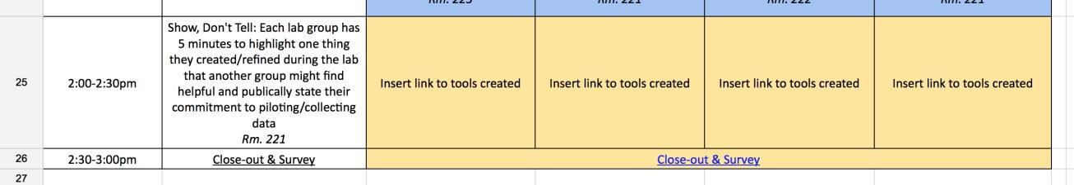

Section 5.3: Lab-Group Specific Next Steps

Please answer the following questions:

Question | Lab Group Response
PILOTING:
- Describe how you will pilot what you have created here.
- What evidence will you need to collect?
- How much data will you need?
- When will you pilot?

SHARING OUT RESULTS:  Pick a date and time right now when this group will come back together, via video conference, to discuss the results of your pilot. | Please invite each member of the lab group, Brent (bmaddin@relay.edu) and Sona (sbaker@relay.edu).  Please use the following Zoom Video Conference as your location: Zoom VideoConference: https://relay.zoom.us/j/9563766888 / Phone: 1-646-568-7788,9563766888  Did you get a meeting on the books: [ ] Yes!
MORE COLLABORATION? Do you want to continue working together as a group to develop what you’ve created even more? If so, signal that to the right, describe how you might work together (e.g., weekly meeting for 30 minutes), and let us know if you’d like TeacherSquared to help facilitate that collaboration.

Section 5.4: Put a Bow On It

Return to the first page of this document make sure all of the following is up-to-date:
- Executive Summary
- Links to materials you have created

ADDITIONAL RESOURCES

